Create and design a marketing campaign for a new Domino’s Pizza
1. In summary
Investigate how you would create and market a new medium pizza to be added to the everyday menu. You will need to produce a business document detailing your new design and justification for decisions.
2. Specific guidance
Become familiar with the existing Domino’s menu https://www.dominos.co.uk/menu/pizza?id=1500&skuId=1762#lsnm=menu+pizza&lspos=1
2.1 Research
2.1.1 Conduct secondary market research to include:
Competitors (those also selling Pizza products both fast food and supermarkets) Who are they, what are they better at doing? What are they not as good at?
Competitors in the wider takeaway food market. Who are they, what are they better at doing? What are they not as good at?
Statistics on consumption of takeaway food and pizza in particular
Identify who are the main target market for fast food products. Who are they? i.e. demographics such as age, gender, income, etc.
2.1.2 Conduct primary market research:
This could be done by creating questionnaires, interviewing individuals, setting up a focus group. Identify trends, likes and dislikes, amount of usage (frequency or days of the week for example). What advertising are they influenced by?
2.1.3 Summarise your findings from both Primary and Secondary research.
2.2 Design
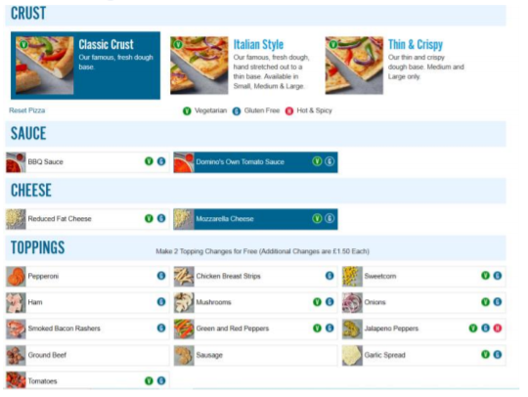
Based on your research to inform decisions design your pizza. You can be creative with your Theme; this could be based on being the ‘healthy option’, on ‘taste and flavour’ or by being ‘innovative-new and different’. You are able to add new options to sauce, cheese and topping but please stick to one of the three existing crusts. Think. How is your theme unique? Does your theme appeal to your target market? How is your theme reflected throughout your proposal? The Pizza itself must be given a name. Consider the nutritious and eat well messages you might like to communicate if relevant, if not how will it attract attention?
2.3 Launching the Pizza. (Read the optional task at the end at this point)
How will you communicate the launch of the new Pizza to potential new and existing customers of Domino’s? Where will you advertise it. How does this link to your target market?
Explain the Unique Selling Point (USP) of your Pizza (a special factor that makes it stand out)
What time of the year will you launch it and why?

3. Conclusion and recommendation
Create your findings into a succinct written document that could be read by a Franchisee of Domino’s. Assume you are pitching this idea to Domino’s. Extract your most interesting findings and designs and put these into a presentation.

Optional task.
Costings for the Launch
Research a combination of different advertising methods and obtain estimates on prices to be charged for these. Evidence where you obtain your estimates on is important. For example, artwork for print advertising campaigns. You may also consider video for social media, a radio script and story boards for broadcast adverts.
Create two examples of potential adverts. For example, design a poster for a Bus Stop or the radio script for whichever radio station most suits your target market.

