A Level Computer Science Gap Task
Y11 into Y12 Preparation work and guidance for students starting A Level Computer Science at CNS
City of Norwich School an Ormiston Academy
A-Level Computer Science
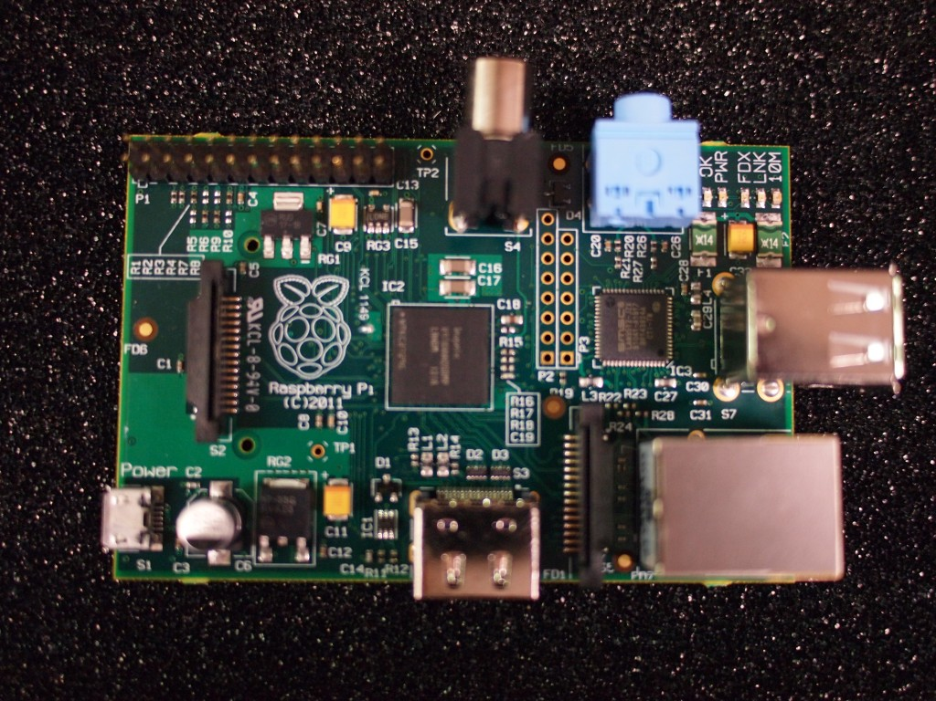
Contents
Course Overview 3
A-level break down 3
Expectations 3
Equipment 4
Your time 4
The Task 5

Course Overview

A-level break down
Content Overview | Assessment Overview
Content is split into 13 teaching units:  - Fundamentals Of Programming  - Problem Solving and Theory of Computation  - Data Representation  - Hardware and Software  - Computer Organisation And Architecture  - Communication: Technology And Consequences  - Data Structures  - Algorithms  - Regular Languages  - The Internet  - Fundamentals of Databases  - OOP and functional programming  - Floating point, adders and d-type flip-flops | Paper 1:  This paper tests a student's ability to program, as well as their theoretical knowledge of computer science from units: 1,2,7,8,9,10 and 13  Assessed through an on-screen exam: 2 hours 30 minutes  Students answer a series of short questions and write/ adapt/extend programs in an electronic answer document provided by us. We will issue preliminary material, a skeleton program (available in each of the programming languages) and, where appropriate, test data, for use in the exam.  40% of the total A level
Paper 2:
This paper tests a student's ability to answer questions from units: 3,4,5,6,11,12 and 13

Assessed through a written exam: 2 hours 30 minutes

Students answer compulsory short-answer and extended-answer questions.

40% of the total A level
Non-examined assessment:
The non-exam assessment assesses student's ability to use the knowledge and skills gained through the course to solve or investigate a practical problem. Students will be expected to follow a systematic approach to problem solving

20% of the total A level

Expectations
• Arrive at lessons on time, ready to work
• Attend all lessons
• Bring the correct equipment to all lessons
• Complete homework tasks on time and to the best of your ability
• Keep your work organised and in a folder
• Play an active role and make a positive contribution to lessons
• Ensure that key assessment dates are written in your planner
• Ask for help if you are unsure

Equipment
Checklist
Pen, pencil, eraser, ruler and highlighter pen
AQA AS and A Level Computer Science Textbook
PM Heathcote and RSU Heathcote
ISBN: 978-1-910523-07-0
PGOnline, £30
Use of the school OneDrive system
Use of your school email (make sure you check your inbox is not full!!)
Ring binder for your daily notes
A set of ring binders for storing your notes for each topic assessment

Your time
Generally an A Level student follows 3 subjects. You have 12 hours of teaching per A level subject over two weeks. So your timetable adds up to 36 hours of teaching over two weeks.
For one week:
Attending 18 lessons (4 A level lessons) | 18 hours
If each teacher sets a HW each week for their part of the course | 12 hours
20 minute review for each period = 18 x 20 minutes | 6 hours
Total Time a week | 36 hours

A lesson review can be in preparation for a lesson; this could involve reading ahead in the textbook. The lesson review can be a follow up to a lesson; this could involve summarisin/consolidating the learning.

The Task
You are expected to demonstrate your level of competence at GCSE level by completing each of these activities.
These activities will be marked to diagnose and assess your readiness for A-level study.
They should be completed and handed-in to Mr Martin by September 17th 2021.
AO1: Recall, select and communicate knowledge and understanding of computer technology
Research and discuss how logic gates are fundamental to computer systems.
You are required to produce a hand written response to this part of the gap task up to a maximum of two sides of A4.
AO2: Apply knowledge, understanding and skills to solve computing or programming problems
A botanist wants to be able to record the species they find in a meadow. They use a quadrat to select 5 areas of the meadow at various points of the year. They would like to be able to record the different species they see and how many plants of that species are present.
Your programmed solution to this problem has the following requirements.
It must:
- Allow the data to be collected and displayed in a tabulated format.
- Be possible to edit the collected data
- Be possible to save the collected data in a CSV format.
It should:
- Allow data to from previous years to be loaded in a CSV format to be edited, displayed or resaved
It could:
- Display the species seen over the year to be displayed in a simple graph on screen to show how many times each species has been found
AO3: Analyse, evaluate, make reasoned judgements and present conclusions
“Recently, the NHS have paused the sharing of data with NHS Direct after many people denied permission for the sharing of their medical data. The NHS want to streamline data sharing between local and national healthcare providers. Some people are very concerned about the potential loss of their very private data into the hands of profiteering corporations.”
Over the next few weeks look for Computer Science related news stories.
Choose one and analyse what its potential impact upon society could be. Present it as if the person reading your analysis has not seen or read the article.
This can be a Word processed response.

