A level Biology
Y11 into 12 Gap task

Name :……………………………………………………………

The task is split into 5 sections, firstly, to enable you to better understand the demands of the A level Biology course and secondly, to allow your teachers to better understand your needs. The 5 sections are as follows:
- Independent study – retrieval practice
- Literacy
- Numeracy
- Practical skills
- Wider reading
Each section will be based on a topic that you will be studying in the first few weeks of the A level Biology course and will begin to build on the knowledge you have acquired from your GCSE studies.
A short video walkthrough of how to complete the tasks can be found here - https://youtu.be/vTlkmNQSOm4

Independent study – retrieval practice
Past students have cited the increased expectation of independent study as one of the biggest demands of studying A level Biology. Roughly speaking, each hour of lesson should be supported by another hour of independent study. This means over a 2 week timetable, you should be doing 12 hours of independent study on top of any homework you are set per subject!
It can be difficult to know what exactly to do for independent study. Simply reading or copying your notes / textbook will not improve how well you can retrieve key information. Instead, make your study strategies generative i.e. retrieving the information from memory with no cues. You can then check what you have retrieved using your notes / textbook and make corrections. This is known as retrieval practice. Doing this regularly (30 minutes a day) is hugely powerful in developing strong memory of the key information needed for the subject.
Retrieval practice can take many forms but here I would like you to try out 2 examples:
Task 1
Below (and on the next page) are labelled diagrams of animal, plant and bacterial cells and the structure of DNA. There is also a table showing the functions of the cell organelles.
Practice “self-quizzing” of the labels / functions of the cells and DNA by redrawing from memory (it doesn’t need to be a work of art!) and checking your drawing against the diagrams. Repeat this every week until you make no mistakes.
Structure of DNA
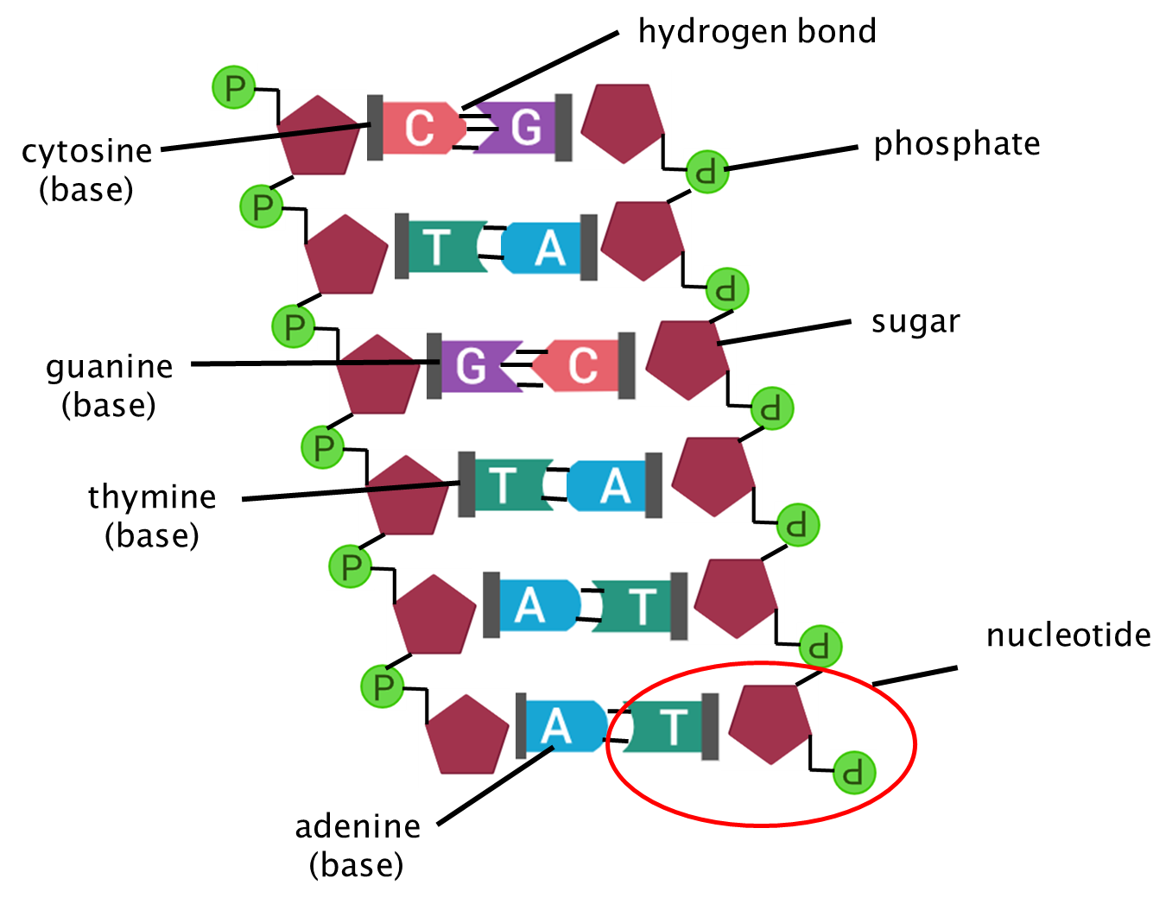

Cells & organelles
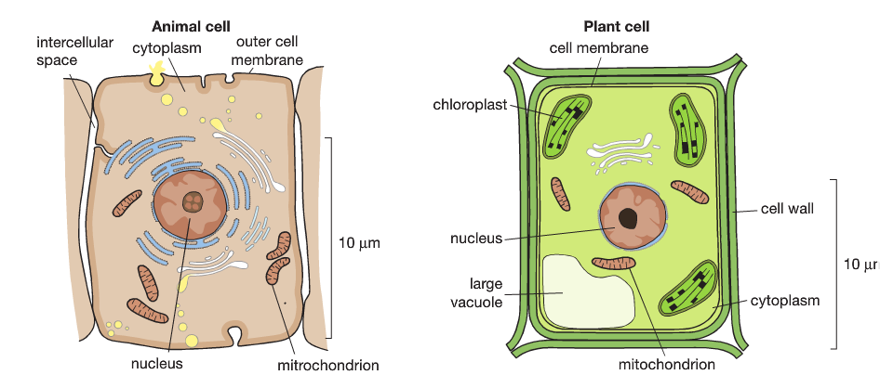
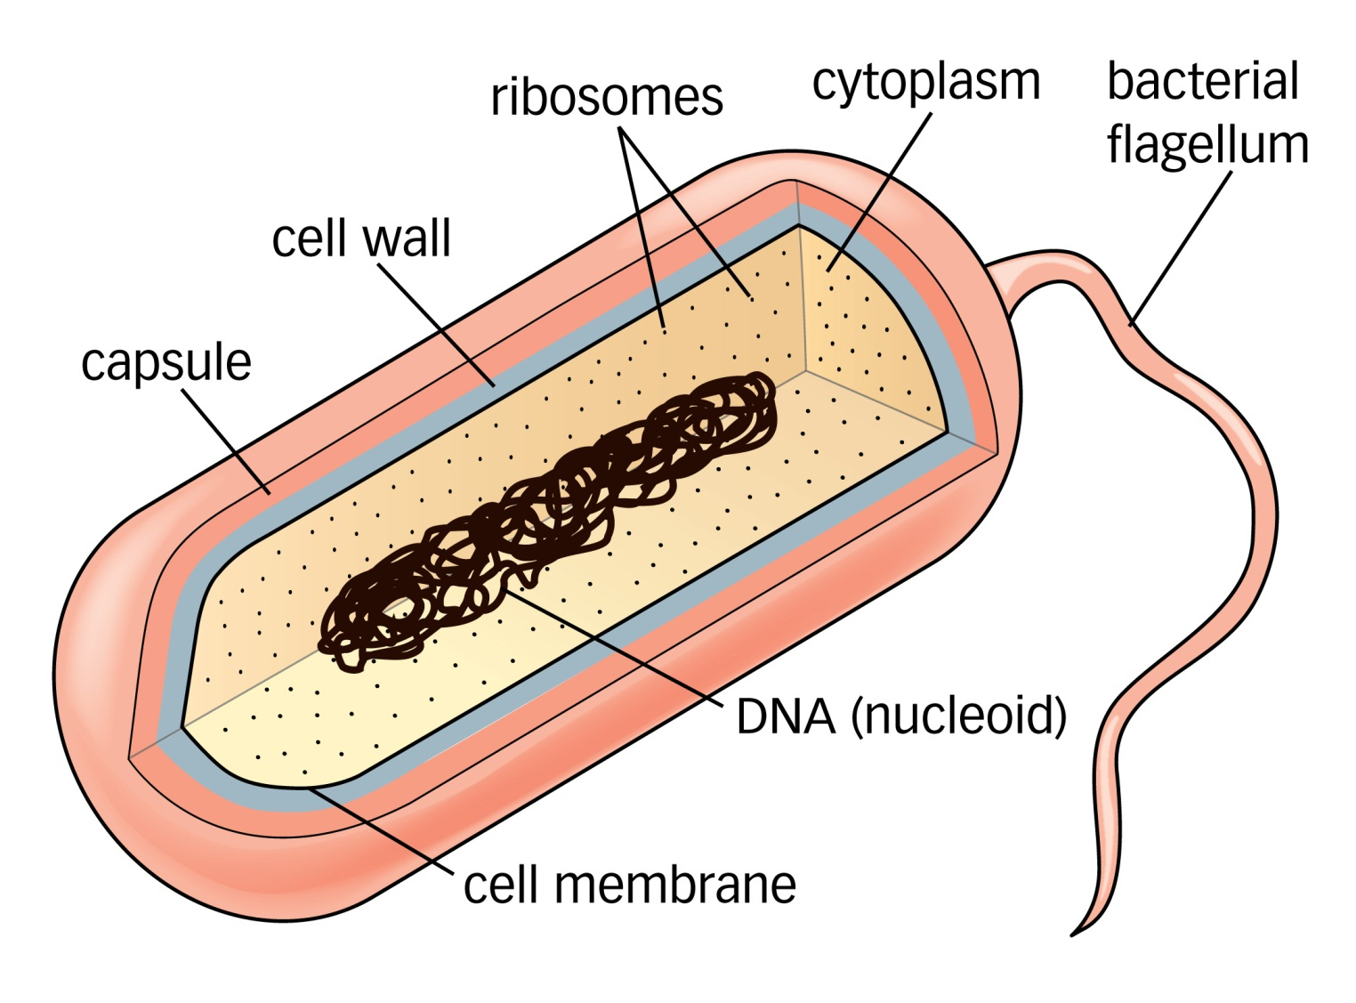
Nucleus | Contains the genetic information (genome) for the cell.
Mitochondria | Site of aerobic respiration where energy in the form of ATP is released,
Cytoplasm | Site of chemical reactions and contains a protein network to allow the movement of substances within the cell.
Cell membrane | Regulates the transport of substances into and out of the cell.
Ribosome | Site of protein synthesis (translation).
Cell wall | Strengthens the cell, preventing it from bursting and maintaining its shape.
Chloroplast | Contains chlorophyll to absorb light energy and site of photosynthesis producing glucose.
Large vacuole | Contains water and dissolved substances and maintains the cell’s shape.
Capsule | Protects the cell.
Flagellum | Allows movement.
Nucleoid | Loop of bacterial DNA not contained within a nucleus.
Task 2
Seneca is an online platform based on the principles of spaced retrieval practice. It is an extremely useful tool for mastering the basic, foundational elements of the A level Biology course.
First of all, I would like you to join the “CNS A level Biology – Gap Task 2022” class I have created by clicking on this link:
https://app.senecalearning.com/dashboard/join-class/sj7l3s1qxz
If you already have a Seneca account, you can also join the class using the class code:
sj7l3s1qxz
I have set you 5 x 30 minute assignments to complete by September. You should complete 1 assignment per week (it doesn’t matter in what order) and aim to achieve 80% success in each module of the assignment. If you achieve below 80%, you should retake the module immediately.
To access the assignments, either use the dashboard on Seneca or use the links below. For more information on using Seneca, please see the Gap Task video.
Assignment 1 –
https://app.senecalearning.com/dashboard/class/sj7l3s1qxz/assignments/assignment/2f7d5a54-1e64-4b83-9bfb-627b1c351c40
Assignment 2 –
https://app.senecalearning.com/dashboard/class/sj7l3s1qxz/assignments/assignment/75f63526-fd98-4d0f-b430-3c103861689b
Assignment 3 –
https://app.senecalearning.com/dashboard/class/sj7l3s1qxz/assignments/assignment/0c8e6363-2312-4d6b-ba1a-3074a5a9000d
Assignment 4 –
https://app.senecalearning.com/dashboard/class/sj7l3s1qxz/assignments/assignment/b2927296-7f7f-474f-a922-b18e1e787556
Assignment 5 –
https://app.senecalearning.com/dashboard/class/sj7l3s1qxz/assignments/assignment/4e987ef8-c9eb-4ba3-8732-d48291c7866a

Literacy
The A level Biology course requires you to write extended responses to exam questions. Not only do these responses need to have a good level of spelling, punctuation and grammar, they also need to utilise specialist scientific vocabulary. Additionally, the exam questions will often use an unfamiliar context that might have new vocabulary for you to decode.
A good technique to use is to use the etymology or morphology of a word to help you understand what it means e.g.
biology
bios -logia
Greek meaning life Latin meaning study
From this we deduce that the word “biology” means “the study of life”. But we can also now deduce the meaning of other words containing “bios” and “logia”.
Task 3
Research and write down the etymology of the following terms you will have learnt at GCSE (a simple Google search works well):
- membrane
- chloroplast
- glucose
- enzyme
- mitochondria
- chromosome
- mitosis
- lipid
- carbohydrate
- organelle
Numeracy
10% of the written exam questions will require you to use level 2 mathematical skills. These include selecting and using appropriate statistical tests, rearranging equations and converting units. Getting your own scientific calculator is a must as you will need to know how to perform various calculations on it and each model is slightly different.
Task 4
Answer the following questions (with appropriate units).
- Convert the following:
  - 42 kg to grams
  - 5 m³ to cubic centimetres
  - 2000 cm² to square metres
- An adult human’s kidneys process approximately 1200 cm³ of blood every minute
  - What is the volume in cubic decimetres?
  - How much blood is processed by the kidneys every second? Give your answer in mm³.
- Round the following numbers:
  - 0.0719 gs⁻¹ to 3 decimal places
  - 8.045 dm³ to 2 significant figures
- Complete the following table:
Ordinary number | 84100 |  |  | 0.000022
Standard form |  | 5.412 x 10⁴ | 7.46 x 10⁹

- Convert the following units to metres and write them in standard form:
  - 1 mm
  - 1 nm (nanometre)
  - 1 µm (micrometre)
  - 1 cm
  - 27 mm
  - 5647 mm
  - 399 cm
  - 29000000 µm
- Calculate the surface area and volume of the following shapes. Show your working:
  - A cube with side length of 5 mm
  - A cuboid with height of 4 mm, width of 3 mm and depth of 1.5 mm
  - A cylinder with a diameter of 2 cm and length of 12 cm
- The body temperatures of 6 people are shown below:

36.7 ⁰C, 37.2 ⁰C, 36.5 ⁰C, 36.2 ⁰C, 36.9 ⁰C and 36.5 ⁰C

  - What is the range of temperatures?
  - What is the mode?
  - What is the median?
  - What is the mean?
- Complete the following table by calculating the percentage increase in plant height. Show your working:
Plant | Height at week 2 (cm) | Height at week 5 (cm) | Percentage increase (%)
1 | 7.6 | 11.4
2 | 6.7 | 10.7
3 | 8.5 | 11.9

Practical skills
As part of your A level Biology studies, you will complete several practical investigations. These are not formally assessed but do combine to form a portfolio known as the Practical Endorsement. At the end of your course you will receive a pass or a fail in this which will go alongside your grade from the exams.
Task 5
Read the method for a practical investigation into enzyme activity. Answer the How Science Works questions about the investigation.
Method
- Clamp the gas syringe securely, angled slightly downward.  - Add 10 ml of 5 % hydrogen peroxide to a conical flask.  - Put the bung securely in the flask and connect to the gas syringe.  - Draw 2 ml of 5% yeast solution and 3 ml of air into a 10ml syringe.  - Connect the 10ml syringe to the flask using the second bung hole.  - Dispense the yeast solution into the conical flask and start timing.  - Record the volume of gas in the gas syringe every 10s, record in the results table.  - Repeat twice more for this concentration using the same conical flask.  - Repeat steps 2 to 8 with 10, 15 and 20 % hydrogen peroxide. | 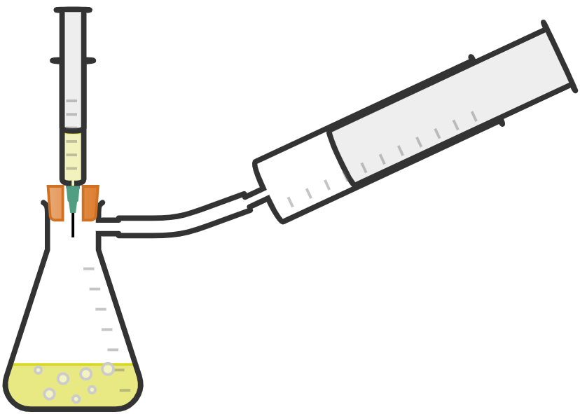

- What is the independent variable in this investigation?
__________________________________________________________________________________________________
- What is the dependent variable?
__________________________________________________________________________________________________
- Suggest a variable that would need to be controlled.
__________________________________________________________________________________________________
- One student suggested that a set of 3 repeats should be completed with 10 ml of water instead of hydrogen peroxide. Why is this a good suggestion?
__________________________________________________________________________________________________
__________________________________________________________________________________________________
- Identify a limitation with the experiment and suggest an alteration that would improve it.
__________________________________________________________________________________________________

Wider reading
You are now studying only 3 subjects and (hopefully!) this is because you really enjoy them! Biology is a wide reaching subject and you will find that your teachers have passions for particular aspects of it. These passions start by discovering information away from the course itself through wider reading.
Task 6
Read the attached article on the role of cell membranes in the ageing process and complete the following tasks:
- Summarise the article in no more than half an A4 page.
- Produce a glossary of any biological / scientific terms used (don’t forget to include some etymology – see task 3).
Task 7
Bring in a Biology based book / article / news story that you have a read and found interesting to share with the class in your first Biology lesson in September. Below are some suggested websites and books for you to explore:
Websites
https://phys.org/biology-news/
https://www.quantamagazine.org/biology/
https://www.newscientist.com/
http://www.bbc.co.uk/news/science_and_environment
Books

The Serengeti Rules by Sean B. Carroll
What is Life? By Paul Nurse
A Short History of Nearly Everything by Bill Bryson
The Body by Bill Bryson
Mutants: On the Form, Varieties and Errors of the Human Body by Armand Marie Leroi
The Ancestor’s Tale by Richard Dawkins
Genome: The Autobiography of a Species in 23 Chapters by Matt Ridley
Power, Sex and Suicide: Mitochondria and the Meaning of Life by Nick Lane
Epigenetics: The Ultimate Mystery of Inheritance by Richard C Francis
The Symbiotic Planet by Lynn Margulis
Microbes and Man by John Postgate

Podcasts / Radio
Ingenious - https://www.bbc.co.uk/programmes/m000h0fy
A 5 part series with each 15 minute episode exploring a single gene, including the ginger gene and the breast cancer gene.
BBC Inside Science - https://www.bbc.co.uk/programmes/b036f7w2
A weekly show exploring whatever science is in the news.
Big Biology - https://www.bigbiology.org/
Big Biology is a podcast that tells the stories of scientists tackling some of the biggest unanswered questions in biology.
Films
Contagion
“Healthcare professionals, government officials and everyday people find themselves in the midst of a pandemic as the CDC works to find a cure.”
Gattaca
“A genetically inferior man assumes the identity of a superior one in order to pursue his lifelong dream of space travel.”
This film explores the issues around genetic engineering and genetic selection.
Creation
“Torn between faith and science, and suffering hallucinations, English naturalist Charles Darwin struggles to complete 'On the Origin of Species' and maintain his relationship with his wife.”
The Immortal Life of Henrietta Lacks
“An African-American woman becomes an unwitting pioneer for medical breakthroughs when her cells are used to create the first immortal human cell line in the early 1950s.”
TV
There are many David Attenborough documentaries on BBC iPlayer that are fantastic, here is a selection of the most recent:
Planet Earth II - https://www.bbc.co.uk/programmes/p02544td
Blue Planet II - https://www.bbc.co.uk/programmes/p04tjbtx
Dynasties - https://www.bbc.co.uk/programmes/p06mvmmr
Aside from Attenborough, there are some other great shows with biology at their heart:
Secret Universe: The Hidden Life of The Cell - https://www.dailymotion.com/video/xzh0kb
Inside Nature’s Giants – search YouTube
Darwin’s Dangerous Idea - https://www.bbc.co.uk/programmes/b00j0c54

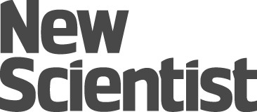

Pill of super-protective ‘heavy’ fat may be key to eternal youth
Bolstering cells with a dose of heavy fat may be the key to curing degenerative diseases. And it may help you hold back the years
By Jessica Hamzelou
Holding back the years
COULD a shiny orange capsule of modified fat help to keep you young? For the first time next month, fats designed to reinforce our cells against age-related damage will be given to people in a clinical trial. The participants have a rare genetic disorder, but if the treatment works for them, it could eventually help us all live longer, more youthful lives, says the scientist behind the work.
Mikhail Shchepinov, director of Retrotope, a biotech company based in Los Altos, California, wants eventually to slow down the ageing process. But he is starting with a related problem – treating the inherited movement disorder Friedreich’s ataxia, with which ageing shares a mechanism. They are both caused, in part, by a molecular attack on our cells. Shchepinov’s idea is to counteract this assault by reinforcing our cells’ defences, slowing the progression of this incurable disease. If it works, it should demonstrate that the approach is also suitable for tackling ageing.
The damage he wants to address is caused by molecules called oxygen free radicals, made when our cells metabolise. Free radicals have unpaired electrons that desperately try to find a partner by tearing electrons off other molecules. This triggers a chain reaction as the denuded atom then does the same to its neighbour.
This chain reaction is particularly dangerous for the fatty acids that form our cell membranes. “They burn like gunpowder until hundreds of thousands are damaged,” says Shchepinov. Proteins and DNA also come off badly. Blocking the reaction should prevent the damage, but Shchepinov has a different idea.
He reckons we can protect our cells from free radicals simply by strengthening the bonds between molecules that make up our cell membranes. This can be done by swapping the hydrogen in the fatty acids for a different form known as deuterium. Because deuterium has an extra neutron, it is heavier than hydrogen and forms stronger bonds (see “The skinny on heavy fat“).
“Swapping some of the fat we eat with stronger fats should allow us to build more robust cells”
Enter the modified fat pill. The idea is that substituting some of the fats we normally eat with modified, stronger fats in pill-form should allow us to build stronger cells. To test the idea, Shchepinov and his colleagues developed heavy versions of an omega-6, polyunsaturated fatty acid. “It’s not a nutrient – it’s a new chemical that is different from the fats you get in your diet,” says Retrotope co-founder Robert Molinari, the biochemist who is leading the clinical trial.
The approach works in yeast – samples that metabolised heavy fats appear to be up to 150 times as resistant to the oxidative stress caused by free radicals as those given regular fatty acids.
The next step is to see whether heavy fat can slow the progression of Friedreich’s ataxia. This is caused by free radical damage to the nerves responsible for movement and usually means people are wheelchair-bound within 10 to 20 years of symptoms appearing. The idea makes sense, says Corinne Spickett at Aston University in Birmingham, UK. “The underlying chemistry is quite correct – the fats are theoretically less susceptible to attack by free radicals,” she says.
The trial launching in June is a safety study. The team will be checking that the doses of heavy fat are well tolerated by 18 people with Friedreich’s ataxia. They don’t expect problems – even if every cell membrane were made from their modified fatty acids, the total amount of deuterium in the body would still be around four times lower than a dangerous dose.
At first, each volunteer will be given two 1 gram tablets of heavy fat per day. “It looks like a fish oil pill,” says Molinari. After a break, the dose will be ramped up, with people taking five tablets, twice a day. Because the heavy fats need to overwhelm the fats we usually get in our food, the volunteers will be placed on a special diet. “They can have olive oil and saturated fats but not polyunsaturated fatty acids,” says Shchepinov.

Reverse the damage
Molinari hopes that the treatment will not only halt the progression of the disease, but also improve people’s symptoms. By replacing cellular fatty acids with stronger ones, there is a chance of rescuing nerves that are sick, but not dead. “A degree of reversal of damage is possible,” he says. “We see improvements in cell experiments – we won’t know about the effects in people until we do the trial.” Although a larger trial will be needed to determine any effect on symptoms, the team is hoping to see some hints during the safety study.
“The principle is sound, and some beneficial effects of heavy fats have been seen in cells and rodents,” says Spickett. “But will this translate to humans? We’ll have to see.”
Theoretically, heavy fats could also prove useful in other diseases in which free radicals are implicated, such as Parkinson’s. A few years ago, Shchepinov and colleagues at the University of Arkansas and the Scripps Research Institute in California, found that a diet rich in heavy fats protected mice against the worst ravages of the mouse equivalent of Parkinson’s disease.
And then there’s the question of whether a heavy fat pill can slow ageing. “If you can fix oxidative damage then lifespan will be extended,” says Shchepinov. “It’s the same mechanism.”
To get a better idea of its potential, the team plans to run a trial in rodents, lasting around three years. A human trial would be more complicated as it would be incredibly difficult to tease apart the many factors known to play a role in ageing (see “Ageing explained“). “The jury is still out on the free radical theory of ageing,” says Mark Cooper at University College London. “Free radicals do contribute to ageing, but there is a massive amount going on – it might not just be down to one thing.”
“Free radicals contribute to ageing, but there is so much going on, it might not just be down to this”

But Shchepinov is sanguine. To him, ageing is just a collection of diseases. If the fatty acids benefit people with these diseases, they will automatically extend lifespan, he says. “Maybe people will live until they are 180 and start dying of something else,” he says. “It’s a complex approach, but I hope our fatty acids will play a role.”

Ageing explained
You’re born, you age, you die. But no one is exactly sure what’s going on under the hood. Here are some ideas about why we age:
Blame the free radicals
When cells metabolise they produce reactive molecules called free radicals that attack other molecules, harming cells in the process. The damage is known as oxidative stress and as it accumulates over time, it is thought to cause the general wear and tear of the body as we age.
Chromosomes worn away
The ends of our chromosomes are capped with bundles of protective DNA called telomeres. These shrink every time a cell divides, until eventually, the telomeres are too short for this to happen. When cell division stops, the cells are unable to replenish themselves and maintain the body’s tissues, leading to age-related disease.
Cells get grumpy in old age
In the 1960s, scientists discovered that cells can only divide a finite number of times – a number referred to as the Hayflick limit. Once you get to this point, however, a cell doesn’t die. Instead, it senesces – it enters a state in which it stops dividing and starts pumping out chemicals that cause damaging inflammation. Researchers are beginning to link senescence to a range of age-related diseases, including Alzheimer’s.

The skinny on heavy fat
What is heavy fat?
Fatty acids are made up of carbon, oxygen and hydrogen. To make a fatty acid, or any other hydrogen-containing molecule, “heavy”, hydrogen is swapped for its heavier isotope, deuterium. The result is a molecule that forms stronger bonds, and is more resistant to damage.
Does heavy fat weigh more than normal fat?
A little bit. An ice cube made of heavy water will sink in a glass of normal water. A mole – a standard unit used in chemistry – of the fatty linoleic acid weighs 280 grams, while a mole of heavy linoleic acid weighs 282 grams.
Will eating heavy fat make me fatter?
Not according to the researchers launching the heavy fat trial (see main story). The fatty acids they want to use as a substitute only make up 1 or 2 per cent of the total energy intake in a normal diet.

