A-Level Physical Education Gap Tasks

Part 1
Complete the exam questions based on the three areas of A-Level PE: Physiology (Applied anatomy and physiology, Exercise physiology and Biomechanical movement), Sports Psychology (Skill acquisition and Sport psychology), Sport and society (Sport and society and the role of technology in physical activity and sport). These question build on your prior knowledge you have gained from GCSE PE, however further research will be required to respond to an A-Level standard.
These questions will go towards you baseline assessment in September, they need to be returned in your first timetabled A-Level PE lesson.
Each section is marked out of 7 marks, total marks 21.
Part 2 – Wider Reading
Once you have completed the exam questions you need to read through the 3 separate readings that are attached.
Reading 1 – Analysis of Performance
Reading 2 – Anxiety in sport
Reading 3 – Technology in sport
Whilst reading though use a highlighter pen to highlight key terms any information that helps with your understanding. This is an important skill for you to develop through Yr12 and Yr13 After each reading we would like you to summarise the reading into a paragraph. In that paragraph please make reference to key terminology, examples to help with understanding and any key take away points you wish to include.
In addition to the readings we would like you to look through the wider reading record we have. This includes books, articles, films, podcasts, tv programmes and many more – there is a huge range to chose from. We would like you to chose one to read, watch or listen to and again summarise it – but this time in a different way than a paragraph. Think mind map, spider diagram, flow chart etc – make it as interesting as you can so that you can remember key points.

Q1.In some games, players kick a ball to keep possession and / or to gain territory.
The figure below shows a footballer kicking a ball.
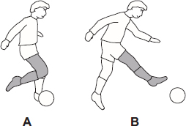
(i) What are the names of the ‘articulating bones’ of the knee joint?
_______________________________________________________________________________
_______________________________________________________________________________
(2)

(ii) In the figure above, what ‘joint action’ takes place at the knee of the kicking leg in the movement from position A to position B?
_______________________________________________________________________________
(1)

(iii) What is the name of the main ‘agonist’ that causes this action in the figure above?
_______________________________________________________________________________
(1)
(Total 4 marks)

Q2.The diagram shows a performer completing a press up.
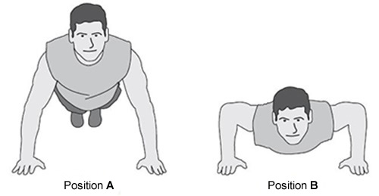
Using the diagram above, complete the table to identify the joint action, the main agonist and type of isotonic contraction at the elbow from position A to position B.

 | Elbow movement from position A to position B
 | Joint action | Main agonist | Type of isotonic contraction

(Total 3 marks)

Q3. Zajonc developed a model to show the effect of the presence of others on performance.
Explain the possible impact of an audience on a performer in the cognitive stage of learning.
_______________________________________________________________________________________________
_______________________________________________________________________________________________
_______________________________________________________________________________________________
_______________________________________________________________________________________________
_______________________________________________________________________________________________
_______________________________________________________________________________________________
_______________________________________________________________________________________________
_______________________________________________________________________________________________
(Total 3 marks)

Q4. All players within a team are likely to experience ‘anxiety’ at some point during their performance.
Identify and explain the different types of anxiety that may affect a performer.
_______________________________________________________________________________________________
_______________________________________________________________________________________________
_______________________________________________________________________________________________
_______________________________________________________________________________________________
_______________________________________________________________________________________________
_______________________________________________________________________________________________
_______________________________________________________________________________________________
_______________________________________________________________________________________________
_______________________________________________________________________________________________
(Total 4 marks)

Q5.State how the technological development of facilities and equipment can help to optimise elite performance.
__________________________________________________________________________________________
__________________________________________________________________________________________
__________________________________________________________________________________________
__________________________________________________________________________________________
__________________________________________________________________________________________
__________________________________________________________________________________________
__________________________________________________________________________________________
__________________________________________________________________________________________
(Total 4 marks)

Q6.Outline the role and purpose of a national governing body in modern day sport.

__________________________________________________________________________________________
__________________________________________________________________________________________
__________________________________________________________________________________________
__________________________________________________________________________________________
__________________________________________________________________________________________

(Total 3 marks)

Reading One – Movement Analysis

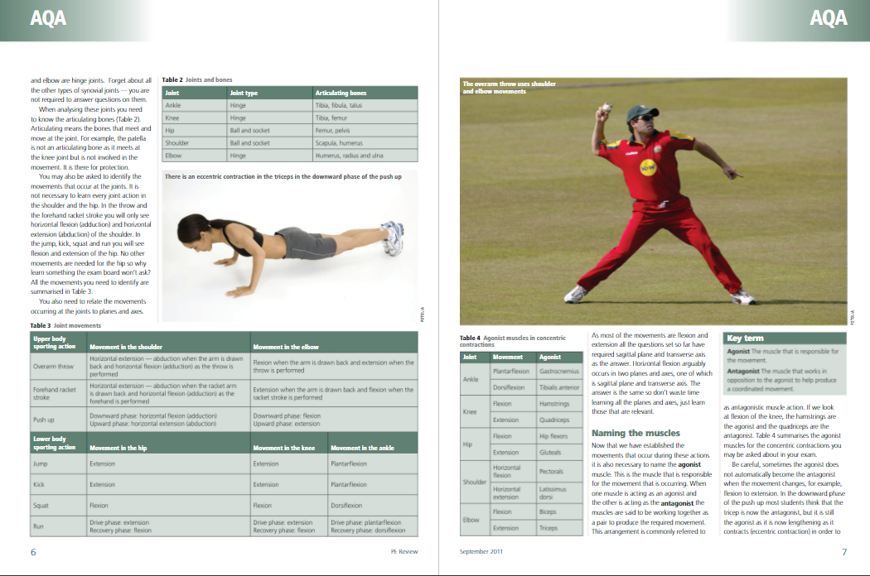
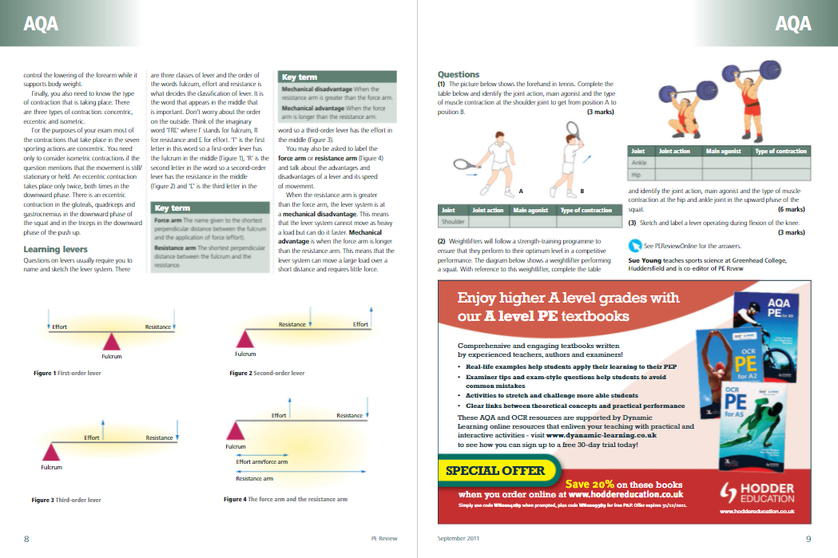

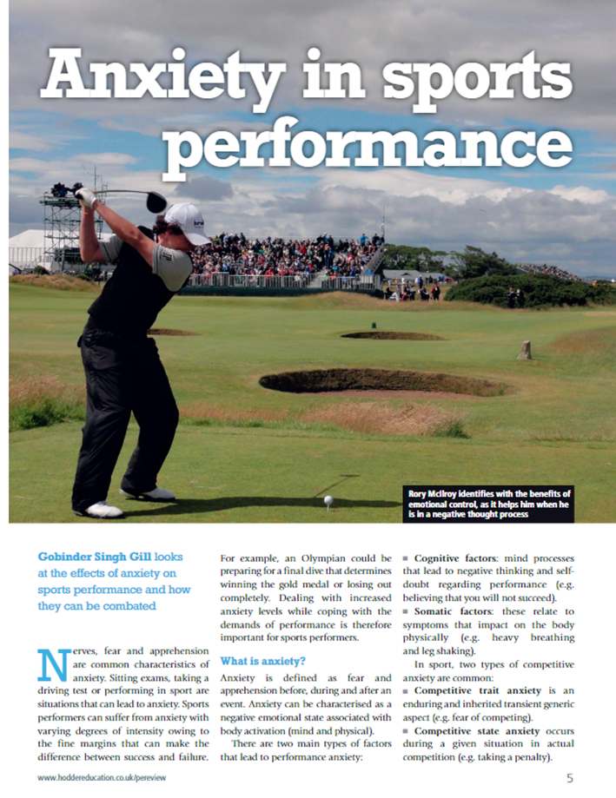
Reading Two – Anxiety
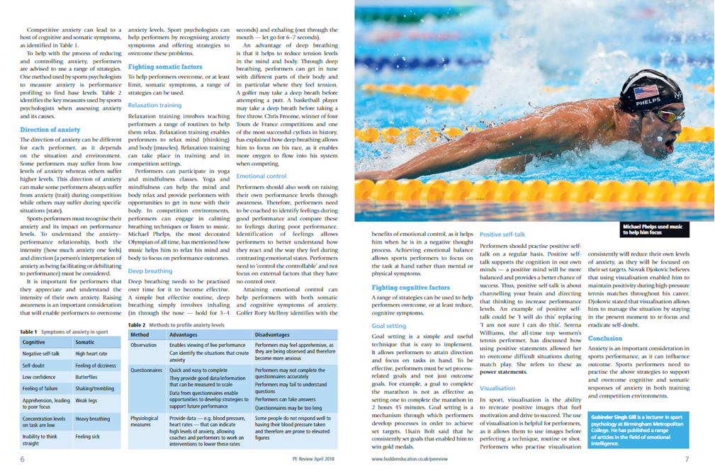
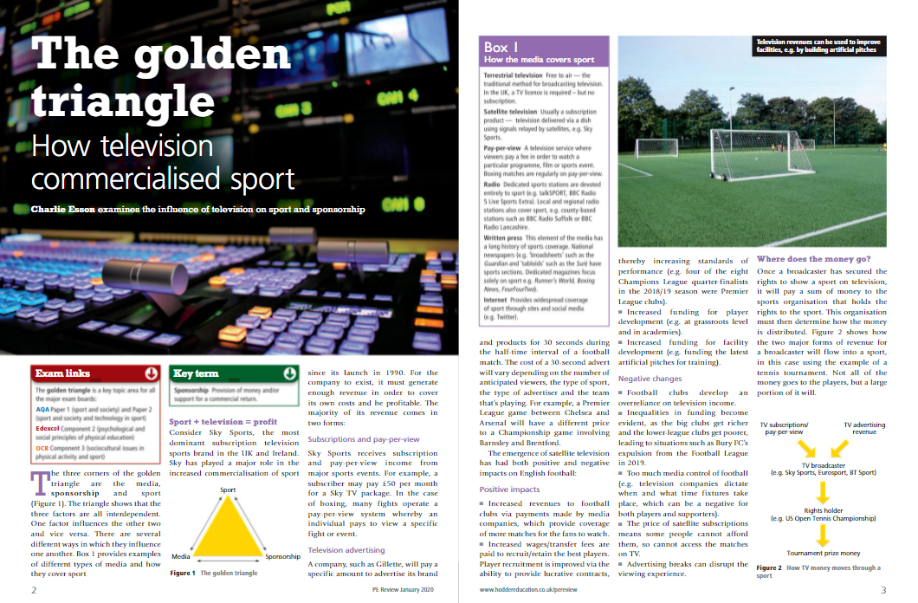
Reading Three – Technology in Sport
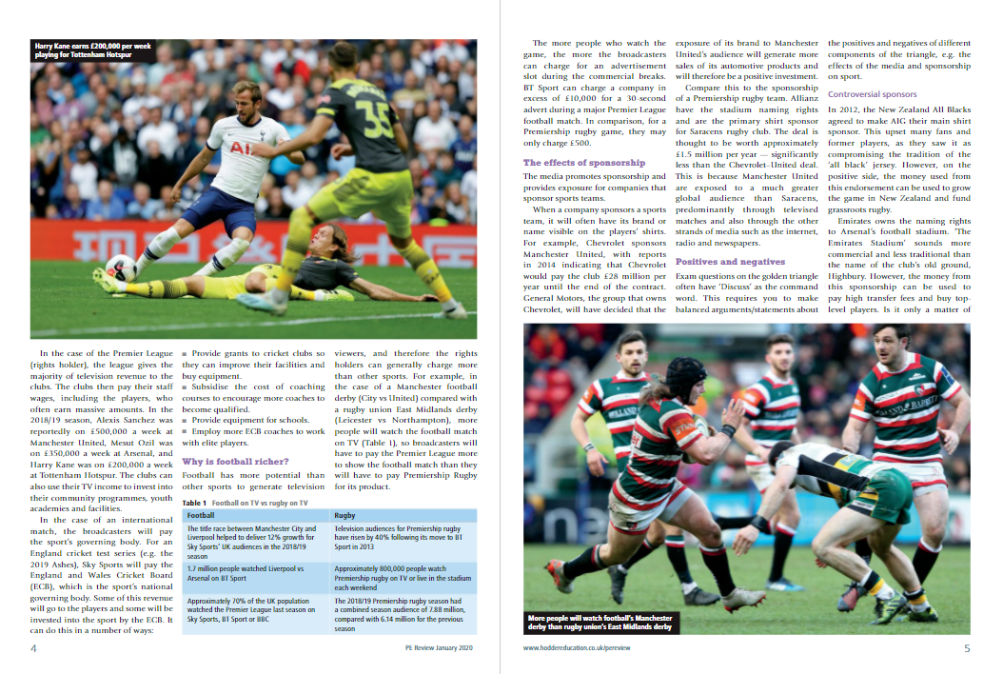

Books / Magazines
Title | Themes: | Recommended by:
A Life Too Short: The Tragedy of Robert Enke - Ronald Reng | Football / All areas of PE & sport science
Among the Thugs - Bill Buford | Football / Football hooliganism
Berlin 1936 – Oliver Hilmes | Olympics / Socio-cultural/historical
Black Box Thinking: The Surprising Truth About Success | Related to sports psychology & society | Miss Chillingworth
Born to Run - Christopher McDougall | Running / All areas of PE & sport science
Bounce – Matthew Syed | All areas of PE & sport science | PE Department
Can We Have Our Balls Back, Please? – Julian Norridge | Various Sports / History of British sport | Mr Pratt
Confessions of a Rugby Mercenary - John Daniell | Rugby / Psychology of sport
Fear and Loathing in La Liga – Sid Lowe | Football / Socio-cultural-historical | Mr Pratt
Fever Pitch – Nick Hornby | Football / Socio-cultural
Football Against the Enemy - Simon Kuper | Football / Socio-cultural-historical
Friday Night Lights – H.G. Bissinger | American Football / Socio-cultural
How to Win – The Secret Footballer & the Secret Psychologist | Football / Sports psychology | Mr Watson
I Am Zlatan - Zlatan Ibrahimovic with David Lagercrantz | Football / Various areas of PE & sport science
I Think Therefore I Play - Andrea Pirlo with Alessandro Alciato | Football / All areas of PE & sport science
Inverting the Pyramid - Jonathan Wilson | Football / Tactics / Historical | Mr Pratt
Journeyman – Ben Smith | Football / Lower league footballer / Socio-cultural
King of the World – David Remnick | Boxing / Ali / Socio-cultural-historical | Mr Pratt
Legacy – James Kerr | Rugby / All Blacks / Psychology / Culture | Mr O’Brien
Little Girls in Pretty Boxes – Joan Ryan | Gymnastics / Various areas of PE & sport science
Living on the Volcano – Michael Calvin | Football / Sports psychology
Mindset – Carol Dweck | Sports psychology
Moneyball – Michael Lewis | Baseball / Talent ID / Socio-cultural | Mr Pratt
No Hunger in Paradise – Michael Calvin | Football / Youth Academies / All areas of PE | Mr Pratt
Open – Andre Agassi | Tennis / All areas of PE & sport science
Outliers – Malcolm Gladwell | All areas of PE & sport science
Outside the Box – Duncan Alexander | Football / Stats
PE Review (Hodder Education) | Various topics | PE Department
Peak Performance – Brad Stulberg | All areas of PE & sport science
Richer Than God - David Conn | Football / Socio-cultural
Sacred Hoops - Phil Jackson | Basketball / Sports psychology
Seabiscuit - Laura Hillenbrand | Horse Racing (USA)
Soccernomics – Simon Kuper | Football / Socio-cultural-historical
The Art of Captaincy – Mike Brearley | Cricket / Sports psychology | Mr Watson
The Artist: Being Iniesta – Andres Iniesta | Football / Various areas of PE & sport science
The Blind Side – Michael Lewis | American Football / Sport science
The Chimp Paradox – Steve Peters | Sports psychology
The Fight - Norman Mailer | Boxing / Ali / All areas of PE & sport science
The Mixer – Michael Cox | Football / All areas of PE & sport science | Mr Pratt
The Nowhere Men - Mike Calvin | Football / Talent ID (Scouting) | Mr Pratt
The Rise of Super Man – Steven Kotler | Extreme Sports / Various areas of sport science
The Secret Race – Tyler Hamilton / Daniel Coyle | Cycling / PED’s / All areas of PE & sport science | Mr Pratt
The Sports Book (DK) | Various sports / History, rules of sport
The Sports Gene – David Epstein | All areas of PE & sport science
The Talent Code – Daniel Coyle | All areas of PE & sport science
The Talent Lab – Simon Timson & Chelsea Warr | Talent ID / UK Sport
Tools of Titans – Tim Ferris | Various areas of PE & sport science
Touching the Void – Joe Simpson | Various areas of PE & sport science
Unforgivable Blackness - Geoffrey Ward | Boxing / Socio-cultural-historical
Winning! – Clive Woodward | Rugby / Sports psychology
My Fight/Your Fight – Ronda Rousey | UFC / Various areas of PE & sport science
Throw Like a Girl: How to Dream Big Believe in Yourself – Jennie Finch & Ann Kilton | All areas of PE & sport science
Unbelievable – Jess Ennis | Athletics / Various areas of PE & sport science
Black, White & Gold – Kelly Holmes | Athletics / Various areas of PE & sport science

Films & Documentaries
Title | Themes: | Recommended by:
A League of Their Own | Baseball / Women in Sport / Socio-historical
All Or Nothing (Documentary – Amazon Prime) | Various / Various areas of PE & sport science
Any Given Sunday | American Football
Battle of the Sexes | Tennis / Gender / Women in Sport
Bend It Like Beckham | Football / Gender / Race / Socio-cultural | Miss Clarke
Blue Chips | Basketball / Socio-cultural | Mr Watson
Borg vs McEnroe | Tennis / Various areas of PE & sport science
Chariots of Fire | Athletics / Socio-cultural-historical
Cheer (Documentary – Netflix) | Cheerleading / Various areas of sport science
Coach Carter | Basketball / Socio-cultural
Concussion | Concussion in US Sports / Injuries | Mrs Clarke
Cool Runnings | Bobsleigh / Culture / Physiology
Cricket Fever: Mumbai Indians (Documentary) | Cricket / Various areas of PE & sport science
Diego Maradona (Documentary) | Football / Various areas of PE & sport science | Mr Pratt
Eddie the Eagle | Skiing / Various areas of PE & sport science
Fever Pitch | Football / Socio-cultural
First Team: Juventus (Documentary) | Football / Various areas of PE & sport science
Fittest in Dubai (Documenatry) | CrossFit / Various areas of PE & sport science
Free Solo (Documentary) | Climbing / Various areas of PE & sport science | Mr Pratt
Friday Night Lights | American Football / Socio-cultural
Gascoigne (Documentary) | Football / Various areas of PE & sport science | Mr Pratt
Hoop Dreams (Documentary) | Basketball / Socio-cultural
How to Make (S1 Ep 1 – The Trainer) | Sport science
Icarus (Documentary - Netflix) | Drugs in sport | Mr Sprake
Invictus | Rugby / Race & politics | Miss Clarke
Invincible | American Football
I, Tonya | Ice Skating / Various areas of PE & Sport Science | Mr Pratt
Last Chance U (Documentary – Netflix) | American Football / Various areas of PE
Living With Lions (Documentary) | Rugby / Various areas of PE & sport & science | Mr O’Brien
Losers (Documentary – Netflix) | Various areas of PE & sport & science
Jerry Maguire | American Football / Sports Agent | Mr Pratt
Miracle | Ice Hockey
Moneyball | Baseball / Talent ID & performance analysis | Mr Pratt
Munich | Olympics / Munich 1972
Murderball (Documentary) | Wheelchair Rugby
No Hunger in Paradise (documentary) | Football / Youth Academies / All areas of PE & sport science
Offside (Documentary) | Football / Socio-cultural
One Day in September (Documentary) | Olympics / Munich 1972
Race | Olympics / Berlin 1936 / Socio-cultural
Remember the Titans | American Football / Socio-cultural | Miss Carroll
Rocky I-V / Creed I-II | Boxing / Various areas of PE & Sport Science | Mr O’Brien
Rush | F1 / Various areas of PE & sport science
Salute (Documentary) | Olympics / Race / Socio-cultural | Mr Pratt
Senna (Documentary) | F1 / Various areas of PE & sport science | Mr Pratt
Stop at Nothing: The Lance Armstrong Story | Cycling / Various areas of PE & sport science
Sunderland ‘Til I Die (Documentary – Netflix) | Football / Various areas of PE & sport science
The Battle of the Sexes (Documentary) | Tennis / Gender / Women in Sport
The Blind Side | American Football / Socio-cultural | Mrs Clarke
The Dawn Wall | Climbing / Various areas of PE & sport science
The Edge (Documentary) | Cricket / Various areas of PE & sport science
The Fall – Decker Vs Budd (Documentary) | Athletics / Various areas of PE & sport science
The Game Changers (Documentary - Netflix) | Diet and nutrition
The Last Dance (Documentary – Netflix) | Basketball / Various areas of PE & sport science | Mr Pratt
The Least Expected Day (Documentary – Netflix) | Cycling / Various areas of PE & sport science
The Mighty Ducks | Ice Hockey / Various areas of PE
The Program | Cycling / Lance Armstrong / Drugs in sport
The Race To Dope (Documentary) | Athletics / Drugs in Sport | A-Level student
The Short Game (Documentary) | Golf / Various areas of PE & sport science
The Wrestler | Wrestling / Various areas of PE & sport science | Mr Pratt
Touching the Void (Documentary) | Climbing / Various areas of PE & sport science
We Are Marshall | American Football / Socio-cultural
When We Were Kings (Documentary) | Boxing / ‘Rumble in the Jungle’
Whip It | Roller Derby / Socio-cultural
White Men Can’t Jump | Basketball / Socio-cultural

Podcasts / Radio Shows
Title | Themes: | Recommended by:
99 Percent Invisible #311 | The Barney Design (Kit design)
99 Percent Invisible #262 | In the Same Ballpark
99 Percent Invisible #234 | The Shift: Redesigning Baseball’s Defence
99 Percent Invisible #199 | The Ying and Yang of Basketball
99 Percent Invisible #127 | The Sound of Sport | Mr Seal
99 Percent Invisible #77 | Game Changer
At Home… (with Colin Murray) - BBC 5 Live | Various areas of PE & sport science
Bunce’s Tales of Extraordinary - BBC 5 Live | Various areas of PE & sport science
Cricket Writers on TV | Cricket / Various areas of PE & sport science
Distraction Pieces Podcast #34 (Dan Hardy) | UFC / Various areas of PE & sport science
Distraction Pieces Podcast #68 (Chris Jericho) | Wrestling / Various areas of PE & sport science
Distraction Pieces Podcast #131 (Rob Parker) | Rugby League / Drugs in sport / socio-cultural | Mr Pratt
Distraction Pieces Podcast #150 (Andrew Beef Johnson) | Golf / Various areas of PE & sport science
Distraction Pieces Podcast #171 (Helen Chamberlain) | Sport & media
Egg Chasers | Rugby
Fight Disciples | Boxing
Fighting Talk BBC 5 Live | Current issues in sport
Flintoff, Savage and the Ping Pong Guy BBC 5 Live | Various areas of PE & sport science | Mr Watson
Football Weekly | Football / Various areas of PE & sport science | Mr Sprake
Full Contact | Rugby / Various areas of PE & sport science
Game of Our Lives Podcast | Football - politics, culture & economics | Mr Pratt
Hawksbee and Jacobs Daily | Various areas of PE & sport science
Inside Sport - BBC Radio Leicester | Various areas of PE & sport science
Optapro Podcast | Performance Analysis
Revisionist History - S2 Ep 1 (A good walk spoiled) | Golf / Socio-cultural
Rugby Union Weekly - BBC 5 Live | Rugby
Sport and the British BBC 4 | How Britain shaped sport and sport shaped Britain
Sporting Witness - BBC 5 Live | Various areas of PE & sport science
Sportsweek - Radio 5 Live | Current issues in sport
Tailenders | Cricket / Various areas of PE & sport science
Test Match Special | Cricket / Various areas of PE & sport science
That Peter Crouch Podcast | Football / Various areas of PE & sport science | Mr Sprake
The Big Interview with Graham Hunter | Football / Various areas of PE & sport science | Mr Pratt
The Bike Show | Cycling
The Cycling Podcast | Cycling
The Football Ramble | Football
The Joe Rogan Experience #737 (Lance Armstrong) | Cycling / drugs in sport
The Science of Sport Podcast | Various areas of PE & sport science | Mr Pratt
The Tennis Podcast | Tennis / Various areas of PE & sport science
The Tim Ferris Show | Various areas of PE & sport science
The Totally Football Show | Football
Who Are Ya? | Football
World Athletics Podcast | Athletics / Various areas of PE & sport science
You’re Dead To Me (Ancient Olympics & History of Football) | Socio-historical / Socio-cultrual | Mr Pratt
Zonal Marking | Football / Football tactics | Mr Pratt

