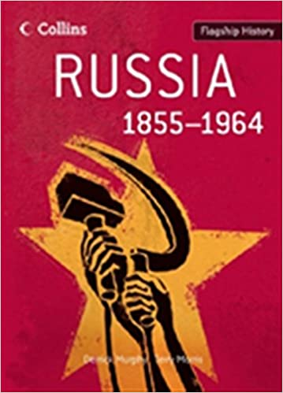
Russia 1855-1964: A synoptic overview
Flagship History

Task:
In A Level History you will often be asked to read a chapter or extract from one of our ‘wider reading’ books.
Please read this introductory chapter to help familiarise yourself with some of the key points of Russian history in the C19th and C20th. This chapter helps you to see the ‘big picture’ of this unit which is a 100 year breadth study (which tackles themes in a way a bit like your ‘medicine through time’ GCSE unit or equivalent).
Please answer the questions below to help you understand the main points of the chapter. Your answers will be discussed in your first History lesson so please bring them in September.

Questions

- What event in the mid C19th was a national humiliation for Russia and what influence did this have on the new Tsar Alexander II?
- Describe the position was Russia in in 1855? (think about geography, economy, government, population, society)
- What significant change did Tsar Alexander bring about in 1861? What do you think the consequences of this might have been?
- What economic transformations had Russia undergone in the 1890s and 1900s?
- How had Stalin turned Russia into a world superpower by the 1950s?
- How had opposition groups demonstrated their political opposition to the Tsarist regime?
- How did the First World War act as a catalyst for the 1917 February Russian Revolution?
- How did Lenin and Stalin intensify repression in Russia after the 1917 October Bolshevik (Communist) revolution?
- Why does the chapter conclude by highlighting two key themes of Russian history: radical reform and political repression.
- +1 How far do you think these themes apply to Putin’s Russia today?

