Name…………………………………………………………………….

**Chemistry Year 11 into year 12 Bridging tasks**

This task is split into 5 sections and is designed to help you develop skills that you will need to do the A level chemistry course and to help you remember some of the fundamental chemistry that you will need.

1. Independent study
2. Wider reading
3. Basic chemical numeracy (18 marks)
4. Numeracy (31 marks)
5. Practical skills (6 marks)

Teacher feedback

1. **Independent study**

Previous students have stated that the increased expectation of independent study is one of the biggest demands of studying A level Chemistry. Roughly speaking you should be spending the same amount of time outside of lessons studying independently as you spend within lessons. This can be difficult, but we are always here to help and guide you through.

This task is an introduction to using wider resources.

1. Open this link: <https://www.youtube.com/playlist?app=desktop&list=PLi6oabjl6coxUlfu8syK3K0iFXQIjwDUM>
2. Watch some of the videos, they are designed to help you transition from GCSE to A level. Choose one and produce a labelled, annotated poster explaining the concept from the video. Perhaps it might be topic you have previously found difficult? You should include a step-by-step guide to help anyone who is struggling with the topic.

You can you other sources to help. E.g. [www.chemguide.co.uk](http://www.chemguide.co.uk)

Bring this to your first lesson.

1. **Wider reading**

You are now studying only 3 subjects and (hopefully!) this because you enjoy them. Chemistry is a wide-reaching subject, and you will find that your teachers have passions for parts of it. These passions started by discovering information away from the course through wider reading.

Bring in a chemistry-based book/article/new story that you have read and found interesting. On the last page you can see some suggested websites and books that you might like to explore.

Bring this to your first lesson.

1. Basic chemistry

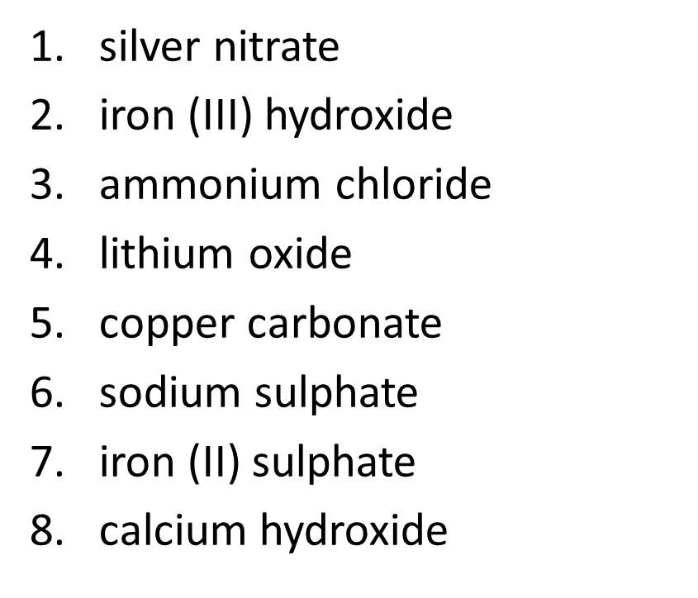**Ionic formula** – work out the formulae of these ionic compounds.

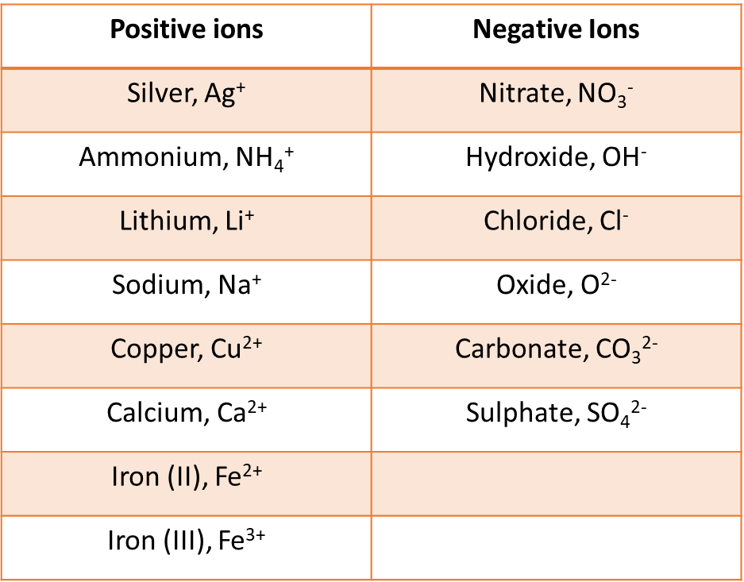

(8 marks)

**Balancing equations**

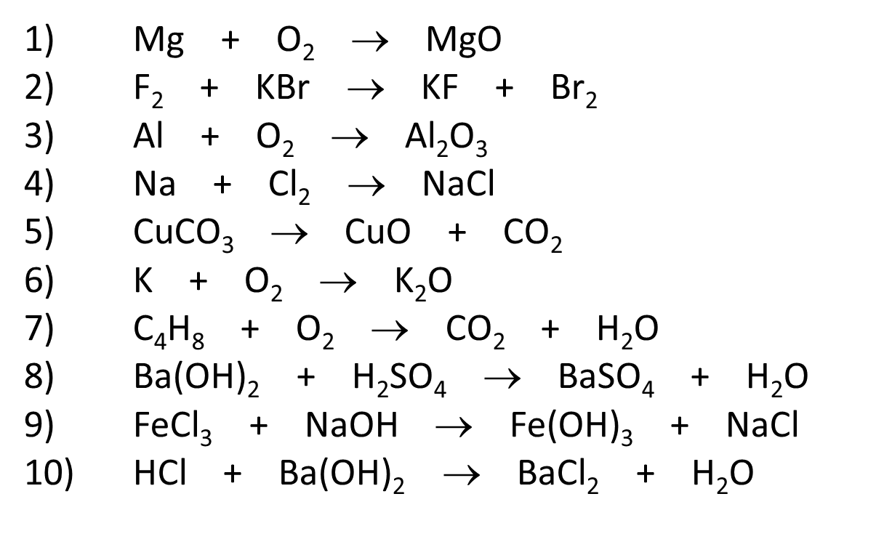

(10 marks)



1. **Numeracy**

**Standard form**

Convert these into standard form:

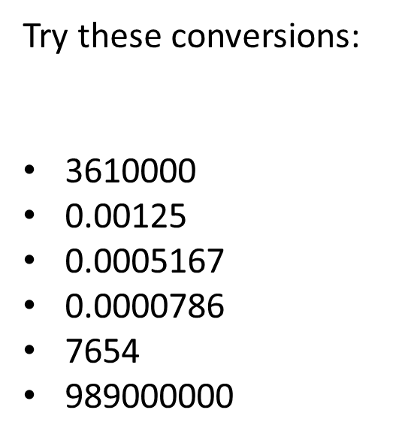

(6 marks)

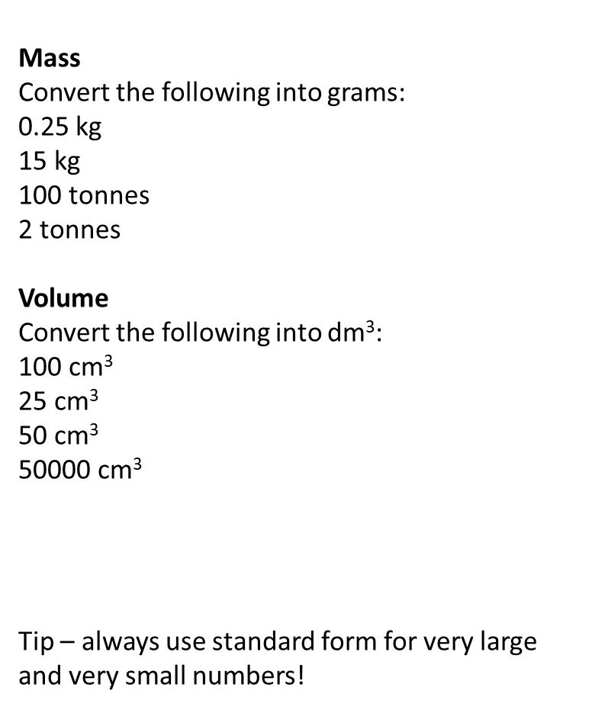**Converting measurements**

(4 marks)

(4 marks)

**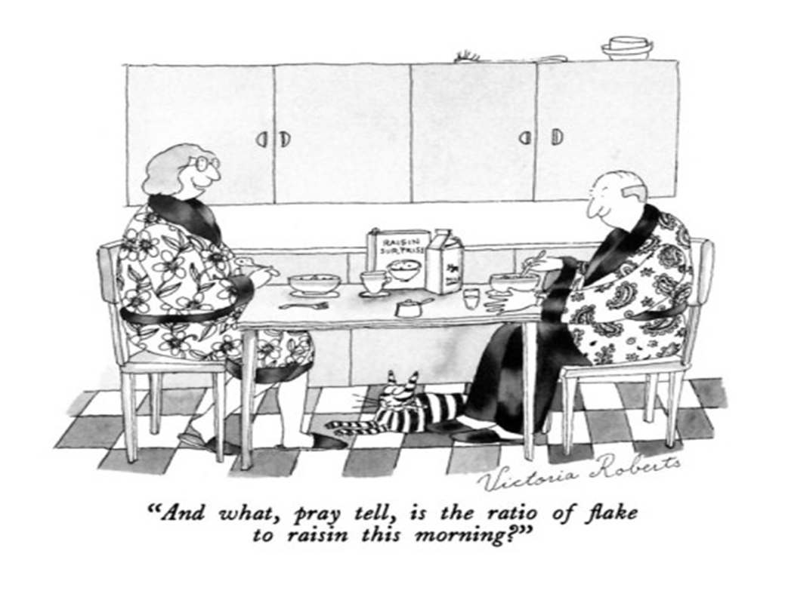Ratio**

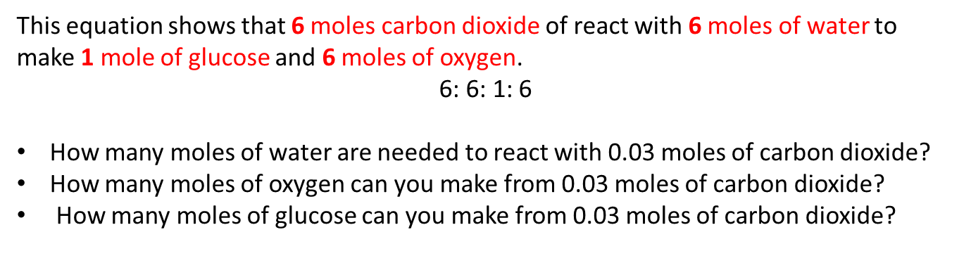

(3 marks)

**Significant figures**

Round these numbers to three significant figures:

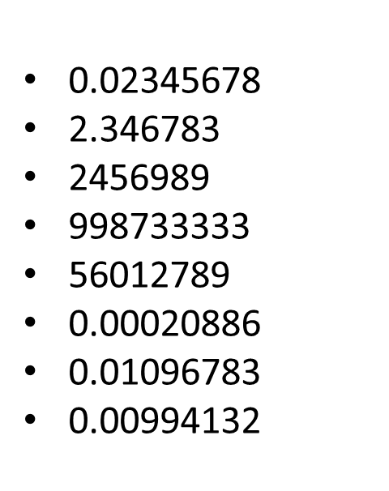

(8 marks)

**Rearranging equations**

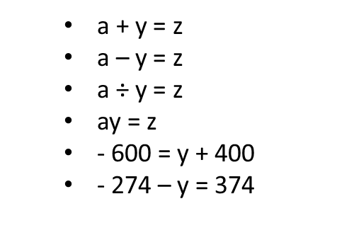Rearrange these equations to make y the subject:

(6 marks)

(6 marks)

