
Summer Gap Task
AQA A Level Psychology

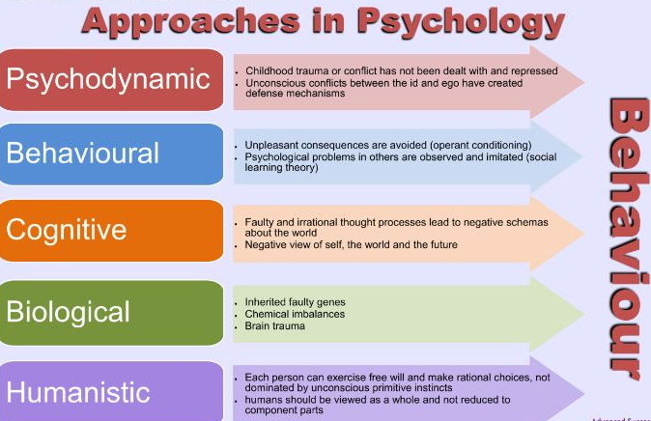
Task 1- Preparation for first unit- NEED TO DO
One of the first units you will study is approaches. These approaches are different ways of explaining human behaviours. Some of these are listed below: your task is to research the fundamental principles of each approach. You can use the internet and YouTube videos to do this.
You should find out: what does this word mean? How might it explain human behaviour? Identify one key researcher from this area – and why are they famous?
- The Behaviourist Approach
- The Social Learning Theory Approach
- The Cognitive Approach
- The Biological Approach
- Optional extension (+1 challenge): The Psychodynamic Approach & Humanistic Approach

Task 2- Reading Task- NEED TO DO
Throughout your Psychology A Level you will be required to read around the topic area regarding key studies, researchers, or disorders. One key study you will look at in the memory section is research conducted by Loftus and Palmer.


Open the link below. This will take you to the journal article which outlined Loftus and Palmer’s study. Read the article and complete the information sheet below. This process will support your summarising skills which is crucial for research tasks within Psychology.

www.demenzemedicinagenerale.net/images/mens-sana/AutomobileDestruction.pdf

List the keywords/concepts. | What does the article tell us? Jot down the key ideas and what they found. This can be in note form.
Summary of the article – what are the key things you have learnt about Loftus and Palmer?

Task 3- Revision Techniques- NICE TO DO
Research in Psychology tells us a lot about the most effective ways to revise information. It is important to know NOW that revision is part of your ongoing learning and not something you do just before you start your exams. Psychologists have shown that regular retrieval practice or testing yourself regularly helps retain information in your mind. As you move through your A level courses and are taught large amounts of information, you need to be regularly testing yourself on learnt material in order to strengthen and retain the knowledge in your mind. If you do not do this, information in your long-term memory quickly decays and then you have to work hard to put the information back into your mind. Revision cards can be an effective method for doing this as long as you use them properly.
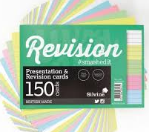
TASK
Your task is to create some revision cards for the material you have just covered. You should aim to produce revision cards on each of the approaches (from task 1) and the key ideas from Loftus and Palmer’s research (task 2). You can then use these revision cards in preparation for your first test in Psychology within your first 2 weeks at CNS.

Guidelines for using revision cards effectively:
- Make the cards as you are learning, either lesson by lesson or week by week. Often students make these when they start revising for exams and this eats into time that should be spent revising and usually there and then so many to make, the task feels overwhelming.
- Do not put too much information on the card. An effective revision card contains a concise summary of information that can be used for quickly testing yourself.
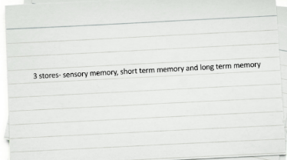
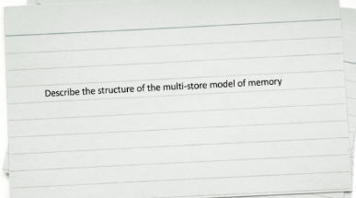

- Don’t just focus on key words. Definitions of key words in Psychology is important but you need more detailed knowledge to answer exam questions effectively. Include key words but also questions that require recall of more detailed knowledge. Try to breakdown your notes into a series of questions and answers, each of which can be added to a revision card.
- Once you have made revision cards, the most important thing is to use these regularly. A really useful system to use involves having different pouches or boxes for these cards. Box one contains all the cards when you have first made the cards. When you test yourself on box one, any that you get right get put into box two and the rest remain in box one. You should re-test yourself on box two about a week later and any you get right again move to box three and any you don’t get right go back to box one. Finally, you should test yourself on box 3 every 3 weeks and move any that you still get right to box 4 which will contain cards that you only need to test yourself on about every 6 weeks (once a school term). Any that you get wrong from any box go back to box one.

