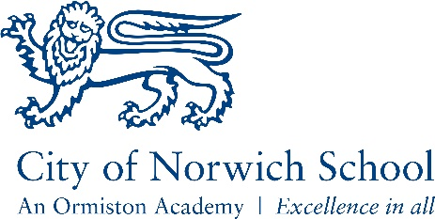
Subject: Health and Social Care
(OCR Cambridge Nationals)
Teacher responsible for the subject: Ms. Thompson
Contact email address: V.Thompson@cns-school.org

This course covers:

- The principles of care.
- Helping individuals find the support they need following life events.
- Planning and delivering creative and therapeutic activities.
Core Textbook:
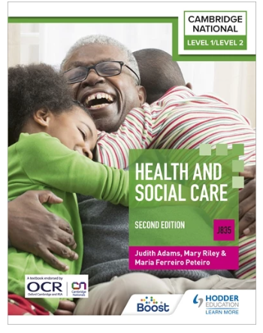
Cambridge National in Health and Social Care

The teachers say: “We love teaching this course because:
“It’s relevant. It covers a combination of theory and practical learning into societal issues and methods of obtaining support”.

The students say: “We enjoy this course because:

“It’s new and makes it feel more interesting. I can understand what’s going on and work out if I want to think about this as a career.”
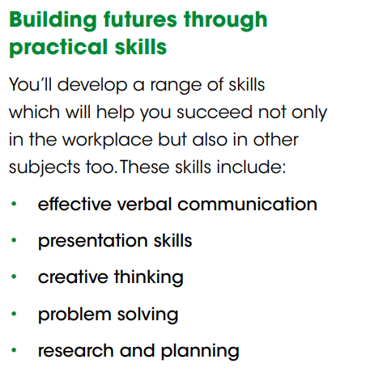
What future pathways might be open to me if I study Health and Social Care?

By developing applied knowledge and practical skills, this course will help give you the opportunity to progress on to A Levels, a Cambridge Technical in Health and Social Care, an apprenticeship or university.
The careers that start from Health and Social Care are endless but may include Nurse, Midwife, Social Worker, Occupational Therapist, or becoming a Paramedic

