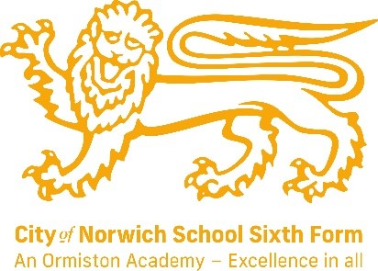
English Language and Literature Combined (AQA)
Subject Leader: Mrs E Jillett
Contact email address: e.jillett@cns-school.org
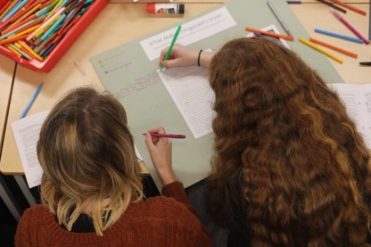
If you love English, we really recommend you read:
- The Yellow Wallpaper (short story) – Charlotte Perkins Gilman
- 1984 – George Orwell
- Atonement – Ian McEwan
- Once in a House on Fire – Andrea Ashworth
- The Bloody Chamber (short story collection) – Angela Carter
- Cat on a Hot Tin Roof – Tennessee Williams

Have you watched our promo video?
Find it at www.cns-school.org > Sixth Form > Curriculum

Recommended Textbooks:
A/AS Level English Language and Literature for AQA ISBN 9781107465664

This course covers the following topics:
Telling Stories (40%)
This part of the course will focus on storytelling and what stories tell us about society. We’ll spend time debating controversial issues that arise from our reading and we’ll discuss the techniques writers use to convey their ideas. During this part of the course, we’ll study the following texts:
- AQA Anthology – a wide range of text types with an emphasis on non-fiction and non-literary material.
- Prose – The Handmaid’s Tale by Margaret Atwood.
- AQA Poetic Voices Anthology – focusing on a range of poems by Carol Ann Duffy.
Exploring Conflict (40%)
This part of the course focuses on how language can be used to construct conflict between characters. We’ll debate the themes and issues that arise from the texts and explore the techniques used by writers. In this section of the course, we’ll help you develop your creative writing skills by asking you to write in the style of a particular author; you’ll also be expected to analyse your creative writing as if it were written by a professional author. During this part of the course, we’ll be studying the following texts:
- A modern prose text e.g. The Great Gatsby by F. Scott Fitzgerald
- A play e.g. A Streetcar Named Desire by Tennessee Williams.

Making Connections (20%) – non-exam assessment
The non-exam assessment (NEA) is a piece coursework that offers students the opportunity to investigate texts of their choice. You’ll receive support to choose an appropriate theme for their work together with fiction and non-fiction texts to study. The NEA allows students creative freedom to follow their own interests and culminates in a 2500 word investigation.

This is a brilliant course because it explores the power of words. In the course, you’ll enjoy considering the way words can be manipulated to convey different messages and emotions. You’ll also get to explore the technicalities of language – the etymology of words and the linguistic devices that can be used to lend power to an argument. The course gives students the freedom to pursue their own interests as they complete their textual investigation.
Our students say:
- ‘I enjoy English combined because the lessons are relaxed and there’s lots of group work.’ – Jacob Y13
- ‘I enjoy English combined because the teachers are great at supporting you and they’re really friendly.’ – Jade Y13
- ‘The best thing about English combined is the way we get to debate controversial issues.’ – Lotte Y12

What pathways are open to me if I study English Language and Literature?
This course will open up lots of opportunities for you in the future. It teaches communication skills and communication is essential to most jobs and courses. Combined English develops your writing skills and many companies require people who can write in a lucid and engaging manner. It also helps you analyse how texts work; this is essential for any job which requires you to read. Here are a few ideas of careers Combined English may prepare you for: teaching, journalism, writing (e.g. magazines, websites, screenplays, novels…) advertising, public relations, speech therapy, psychology, forensic linguistics, translator / interpreter.

