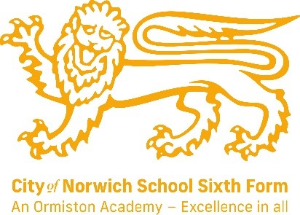
English Literature (AQA)
Subject Leader: Mrs E Jillett
Contact email address: e.jillett@cns-school.org
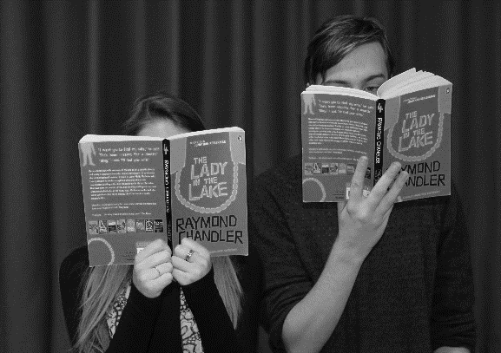
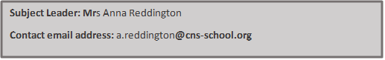
Have you watched our promo video?
Find it at www.cns-school.org > Sixth Form > Curriculum

If you love English Literature, we really recommend you read:
- The Great Gatsby by F. Scott Fitzgerald.
- Great Expectations by Charles Dickens.
- Jane Eyre by Charlotte Bronte
- The Handmaid’s Tale – Margaret Atwood
- The Bloody Chamber (short story collection) – Angela Carter
- Tess of the D’Urbervilles – Thomas Hardy
- Frankenstein – Mary Shelley

Recommended Textbooks:
A/AS Level English Literature A for AQA Student Book ISBN 9781107467927

This course covers the following topics:
Love through the ages (40%)
This part of the course will focus on the theme of love as seen in literature over time. We’ll spend time debating the themes and issues raised in the texts while considering how they reflect the time period in which they were written. During this part of the course, we’ll be studying the following texts:
- A play by Shakespeare e.g. Othello.
- A novel: e.g. Wuthering Heights by Brontë.
- AQA Anthology of Love Poetry – featuring a range of post 1900 poets.
Texts in shared contexts (40%)
The aim of this topic area is to explore connections between texts written within a particular time period. During this part of the course, we’ll be studying the following:
- One prose text e.g. Oranges are not the only Fruit by Jeanette Winterson
- One poetry text e.g. Feminine Gospels by Carol Ann Duffy
- One drama text e.g. Cat on a hot tin roof by Tennessee Williams.
Independent critical study: Texts across time (20%)
For this part of the course, students will write a 2500 word critical study that focuses on two texts. Students will have the freedom to choose the focus of their critical study together with one of the texts. However, they’ll receive lots of support from their teachers so that they produce the best possible work.

English Literature is a brilliant course because we get to explore a range of texts from different genres and time periods; what unifies these texts is the way they allow us to explore what it means to be human. Some of these writers were living a long time ago, yet many of the experiences they explore in their writing are as relevant today as they were in the past. We enjoy discussing love, relationships, jealousy, envy, gender relations… The list is endless. We also enjoy guiding students as they pursue their own interests in their independent critical study.
Our students say:
- ‘I enjoy English literature because it opens your mind to new ideas.’ – Jade Y12
- ‘English Literature gives us the opportunity to debate contentious issues.’ – Ben Y12
- ‘I appreciate the care and support that our teachers give us.’ – Izzy Y13

What future pathways are open to me if I study English Literature?
English Literature will open lots of opportunities for you in the future. It teaches communication and critical thinking – skills that are essential to many jobs. English Literature is also regarded as a highly academic subject; a good grade in the subject can tell prospective employers that you are an intelligent, deep thinker. These traits are valuable to a range of professions, but here are a few ideas of careers English Literature may prepare you for: teaching, journalism, politics, research, law, editing, publishing, lecturing, acting.

