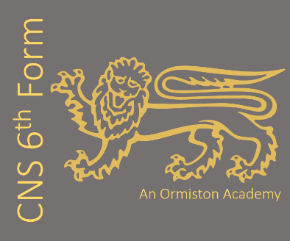
Film Studies (EDUQAS)
Subject Leader: Mrs E Jillett
Contact email address: e.jillett@cns-school.org
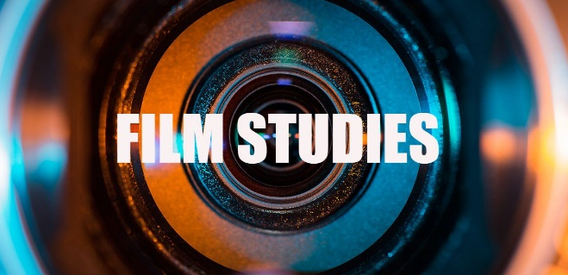
If you love film, we recommend you watch:
- Psycho (1960) Alfred Hitchcock
- Dunkirk (2017) Christopher Nolan
- Blade Runner (1982) Ridley Scott
- We need to talk about Kevin (2011) Lynne Ramsey
- Promising Young Women (2020) Emerald Fennell
- The Grand Budapest Hotel (2014) Wes Anderson

Have you watched our promo video?
Find it at www.cns-school.org > Sixth Form > Curriculum

Recommended Textbooks:
EDUQAS Film Studies for A Level and AS. ISBN: 978-1-911208-44-0
EDUQAS Film Studies for A Level and AS Revision Guide. ISBN: 978-1-912820-35-1

Course content
A level Film Studies combines the study of existing movies with the opportunity to create your own films. We’ll be assessing your grasp of the theory by asking you to put the theory into practice through film making tasks. The course comprises the following components:
Varieties of film and film making – 35%
This component of the course will involve studying six British and Hollywood feature length films from the 1930s through to the present day. The films studied include: Vertigo (Hitchcock), Carol (Haynes), Get out (Peele), Bonnie & Clyde (Penn), This is England (Meadows), Fish Tank (Arnold).
Global film making perspectives – 35%
This component focuses on five films which include: global film, documentary film, silent cinema and experimental film. Films studied include: House of Flying Daggers (Yimou), Mustang (Erguven) and Memento (Nolan), Stories We Tell (Polley), the films of Buster Keaton.
Production – non-exam assessment – 30%
For the non-exam assessments, you’ll be researching, planning and producing a short film of between 4 and 5 minutes. You’ll also evaluate this work assessing: narrative structure, cinematic influences and impact on the audience.

Most people watch hundreds of films during their lives, but they don’t always consider the messages, values and representations that are conveyed through film. Nor do many really consider the process of film production and the way that relatively simple techniques – camerawork, sound, editing and performance – can create something that has the power to make us laugh, cry, feel angry or impassioned. We love teaching film studies because we enjoy helping students understand these aspects of film; we also enjoy seeing them try these techniques for themselves as they go out and produce their own short movies.
Our students say:
- ‘Film Studies has inspired me to pursue a career in film making’ – Esme Y13
- ‘I enjoy the way film studies introduces me to new ideas and new ways of thinking about the world’ – Tom Y13
- ‘I enjoy the practical side of the course – we get to make our own films.’ – Reuben Y12

What future pathways are open to me if I study film?
A Level Film Studies is a fantastically wide-ranging course and as a result our students go on pursue a variety of careers. The course is excellent preparation for higher education courses in Media Studies, Media Production, Film Studies, Cultural Studies, English and other arts-based courses. We also have students move straight into working in film and the Media. We have ex-students working in advertising, TV production, journalism, web design and graphic design.

