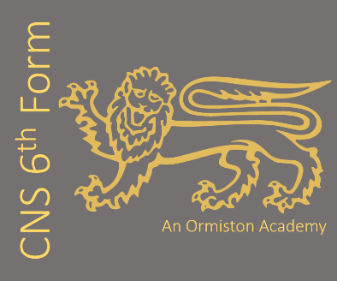
Subject: Fine Art (AQA)
Subject Leader: Mrs Howarth
Contact email address: h.howarth@cns-school.org
This course covers the following key topics:
Students can work in one or more of these traditional and contemporary media:
- Drawing and painting (using pencil, charcoal, pastels, acrylic, oil, or watercolour)
- Mixed media (including collage and assemblage)
- Sculpture (carving, casting, or modelling with clay, wood, metal, or stone)
- Printmaking (relief, intaglio, screen processes, and lithography)
- Moving image and photography (video, film, and animation)

Assessment Objectives (AOs)
- AO1: Develop ideas through focused investigations and contextual sources.
- AO2: Explore and select media, materials, and techniques, refining your ideas as you go.
- AO3: Record ideas, observations, and insights, reflecting critically on your progress.
- AO4: Present a personal and meaningful final respons
Recommended revision resources and wider learning:
AQA Fine Art

ArtPedagogy

BBC Civilisations

ArtRabbit

Recommended reading:

The Story of Art Without Men by Katy Hessel

The Whole Picture: The colonial story of art in our museums & why we need to talk about it by Alice Procter

Ways of Seeing by John Berger

We love teaching this course because:
promotes critical thinking, global awareness, communication, problem-solving, creativity and imagination. All these skills are intended to support students preparing for their next steps beyond secondary education and to help them become confident global citizens in the twenty-first century.

Our students say:
“Art teaches you problem solving skills and to never give up.”
“I enjoy losing myself in the process of making art.”
“Fine Art can help you with your emotional wellbeing.”
“It makes be feel good when I complete a painting, like I have accomplished something for myself.”
“It allows me to express myself and to go in any direction I want to.”

What future pathways are open to me if I study Fine Art?
Foundation degree or a degree in creative and/or expressive arts, leading to a variety of careers in the creative industries, including Fine Art, Illustration, Architecture, Animation, Film, Gaming, Photo Imaging, Publishing, TV, VFX, Special Effects, Advertising and Marketing and Communications.

