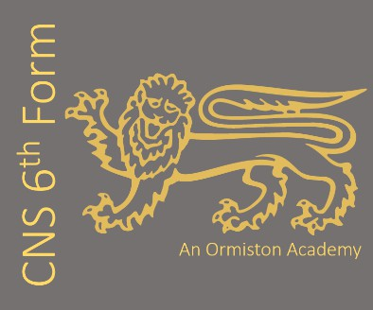
Subject: WJEC Level 3 Alternative Academic Qualification in Food Science and Nutrition (Extended Certificate – E – A*)
Subject Leader: Mrs. J Craddock
Contact email addressj.craddock@cns-school.org
This course covers the following key topics:
Year 1 (YR 12)​
- Unit 1 - Nutritional needs across the life stages ​
- Unit 2 – Developing practical food production skills ​
Year 2 (YR 13)​
- Unit 3 – Principles of food hygiene and food safety in food production ​
One of the following units: ​
- Unit 4 – Experimenting to solve food production problems ​
- Unit 5 – Current Issues in Food Science and Nutrition ​

Recommended Textbooks:
1)WJEC Level 3 Food Science and Nutrition
2)The Science of Cooking Every Question answered to perfect your cooking – Dr Stuart Farrimond
3)Spoon Fed: Why almost everything we have been taught about food is wrong – Tim Spector

We love teaching this course because: It is a great foundation for a career in any job in the food industry. There is great variety and range of content which focuses on real life issues facing the world. It suits both scientific and practical learners as students develop academic skills for future studies and practical skills for the workplace at the same time. It’s a great course for students who want to maintain an interest in food but don’t want to commit to a vocational course and limit their career options.
Our students say:
“I wanted to continuing studying food as I really love it but didn’t want to be a chef, so this course lets me keep learning about food but get a academic qualification as well.”
“I enjoy learning about nutrition and it really ties in with Sports Science
which I also study”
“I wanted to pick a practical subject whilst not harming my University
prospects and the course has a really good blend of this”

If you love Food, we really recommend you read:
1) Cooking for Geeks by Jeff Potter
2) National Dish by Anya von Bremzen
3) The science of food by Marty Jopson
4) Zaitoun by Yasmin Khan
5) Hibiscus by Lopè Ariyo
6) Flavor + Us: Cooking for Everyone by Rahanna Bisseret

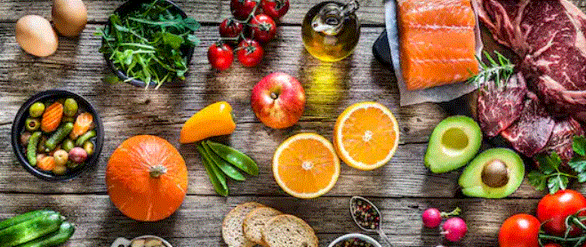
What future pathways are open to me if I study Food Science & Nutrition
- BSc Food and Nutrition
- BSc (Hons) Public Health Nutrition
- BSc (Hons) Food Science and Technology
- BSc (Hons) Food & Nutritional Science and Psychology
- BSc (Hons) Food Technology and Product Development
- Careers in the food industry ww.tastycareers.com

