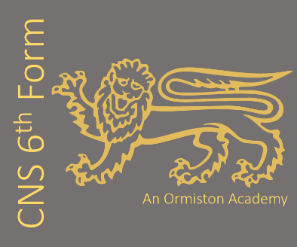
Subject: History (AQA)
Subject Leader: Miss H Dimsdale
Contact email address: h.dimsdale@cns-school.org

If you love Russian history, we really recommend you read:
1) Orlando Figes, Revolutionary Russia
2) Robert Service, The last of the Tsars
If you love 17th Century history, we really recommend you read
3) Peter Ackroyd, Civil War
4) Blair Worden, The English Civil Wars
Recommended Textbooks:
- Oxford AQA History: Tsarist and Communist Russia, 1855-1964

- Oxford AQA History: The English Revolution, 1625 - 1660

This course covers the following key topics:
Unit 1H – Tsarist and Communist Russia, 1855-1964. A breadth study of the political, social and economic changes in Russia, comparing the different styles of authority and leadership between autocratic Tsars and Communist leaders.
Unit 2E – The English Revolution, 1625-1660. A depth study of the political and religious upheaval of the English Civil War and the political experiments of Oliver Cromwell.
NEA coursework – The Civil Rights Movement in America, c.1860-1970. An independent investigation of the development of African American Civil Rights where students produce an extended piece of writing.

We love teaching this course because
The two units we teach complement each other perfectly; students can see common historical trends and themes reflected in both topics and draw out comparisons and parallels between them. The course offers students the chance to delve deeper into the periods we study which really helps students’ confidence and depth of knowledge. Additionally, both topics explore some extraordinary characters (e.g. Charles I, Oliver Cromwell, Nicholas II, Stalin) that by the end of the course students feel like they really know them! As well as being a great selection of topics, the History A Level also provides an excellent opportunity to develop important skills such as analysis, critical thinking, argument and extended writing. As a teacher it is always very humbling to see students’ writing mature over the two years and leave us with a sense that they have become academics themselves.
Our students say:
“I enjoy history A Level because it evokes critical and argumentative style of thinking”
“The History A Level course so far has opened my eyes to a part of the past that I previously knew nothing about. It is really interesting to learn about something that changed England so significantly.”

What future pathways are open to me if I study History?
Media, journalism and broadcasting
Politics, policy, civil service and law
Heritage industry
Communications, PR, marketing, business
Teaching/academia

